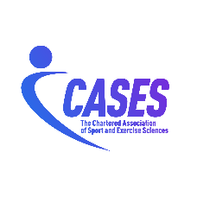

MEMORANDUM OF UNDERSTANDING

A partnership between

The International Society of Qualitative Research in Sport and Exercise
and
The Chartered Association of Sport and Exercise Sciences

- Objective
  - This Memorandum of Understanding (MoU) outlines the agreed collaborative relationship between the International Society of Qualitative Research in Sport and Exercise (QRSE) and the Chartered Association of Sport and Exercise Sciences (CASES) for the purposes of enhancing the activities of each organisation and fostering co-operation in international context for the benefit of all professionals involved within the respective organisations.
  - Relationship: CASES and QRSE wish to develop a mutually respectful relationship that reflects an understanding of each other’s area of remit and expertise and supports practitioners in their field.

- Background
- QRSE, founded in 2020, is a professional organisation dedicated to promoting, advancing, and connecting qualitative research in the sport and exercise sciences. The society provides an international home for qualitative researchers across disciplines and welcomes all methods, methodologies, traditions, epistemologies, ontologies, and forms of empirical inquiry that fall within the broad umbrella of qualitative research. Reflecting its multidisciplinary nature, QRSE brings together researchers from fields including sport and exercise psychology, sociology of sport, sport coaching, sport pedagogy, leisure studies, sport management, sport policy, sport and exercise medicine, and related disciplines.
- CASES (formerly BASES; formerly BASS) was founded in 1984. In May 2024, BASES was granted the Charter of Incorporation by His Majesty King Charles III. On 1 April 2025, BASES was incorporated as The Chartered Association of Sport and Exercise Sciences (CASES). CASES is the professional body and membership association for sport and exercise sciences in the UK. CASES’ mission is to innovate, advance knowledge, promote best practice and advocate the profession by building a collaborative and inclusive sport and exercise science community. CASES has a range of accreditations and endorsements that maintain high standards in sport and exercise science, providing a quality assurance framework for practitioners and laboratories.
- Per the Royal Charter, CASES’ objects are:
i) the promotion of research in sport and exercise sciences.
ii) the encouragement of evidence-based practice in sport and exercise sciences.
iii) the distribution of knowledge in sport and exercise sciences.
iv) the development and maintenance of high professional standards for those involved in sport and exercise sciences, and
v) the representation of the interests of sport and exercise sciences nationally and internationally.

- Collaboration

3.1 News Sharing:
    - Newsletters - Both organisations agree to share information when provided by the organisation within their newsletters as and when appropriate.

  - Professional Development:
    - Live Webinars - CASES and QRSE members to access at reciprocal member costs.
    - Collaborative CPD - CASES and QRSE to explore opportunities to collaborate on webinars, short courses, workshops and other resources.
    - Conferences
      - Promotion of conferences - CASES and the QRSE to reciprocally promote each other’s conferences to their members.
      - Presence at conferences - Agree to be present at each other's conference e.g., may be physical presence (cost to be carried by their own organisation) or promotional materials.

  - Sharing of expertise
    - This MoU encourages expertise sharing and collaborative working between CASES and QRSE.
    - Collaborate where appropriate on expert statements or position stands.

- Review
  - Both parties commit to at least one partnership review meeting per year. Within these meetings, the review of existing partnership arrangements will take place, as well as examining scope for further expansion of the partnership.

  - The MoU can be amended at any point by unanimous agreement.

- Confidentiality
  - Both parties commit to complying with any applicable privacy legislation in their jurisdiction regarding any personal information they receive about the members of the partner organisation. This provision will survive termination of this MoU.

  - Both parties agree not to disclose any information or documents which comes to its knowledge or into its possession by reason of this MoU which the other partner organisation has explicitly or implicitly indicated as confidential unless otherwise pursuant to judicial or legislative authority in the respective jurisdiction. This provision will survive termination of this MoU.

- Term
  - This MoU will last until September 2029. CASES and QRSE will evaluate this agreement mid-term and determine whether to extend the term for another year.

For QRSE  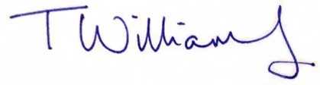 | For CASES  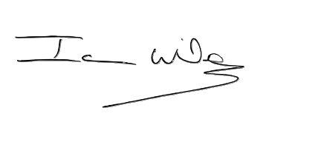
Name: Toni Williams | Name: Ian Wilson
Post: President | Post: Chief Executive Officer
Date: 10 October 2026 | Date: 6 October 2026

