Solutions-oriented communication: a guide for technicians.

I - Rationale.

The Chartered Association of Sport and Exercise Sciences (CASES) Technical special interest group has been primarily established to connect technicians and break down barriers.

The main aims of this document are: (i) to provide guidance and potential solutions to solve conflicts within the workplace, and (ii) to raise awareness on the importance of adopting a structured approach to resolve conflict.

The benefits of conflicts’ resolution include improving communication and problem-solving skills as well as relationships and productivity. The guidance provided herein is intended to reduce the likelihood that conflicts escalate to a greater extent and become difficult to manage. This document content aligns with fairness, professionalism and honesty which are part of CASES’ values.

Image: Unsplash.com

II - Conflict definition and background.

“Conflict is the disagreement or difference of opinions between or among individuals that can be potentially harmful to any organisation” ⁽¹⁾. Conflict, a state of opposition, leads to divide people and raises barriers in the workplace.
Conflicts are usually caused by changes, poor communication and stress but are also related to behaviour, emotions or perception ^{(2, 3)}. Although often perceived as negative, conflicts can be beneficial to a team or individuals as their resolution can lead to changes in ways of working and better communication.

III - Conflict management styles - The five conflict handling modes by Thomas & Kilmann ⁽⁴⁾

Although each conflict is unique, there are several ways of managing them.

Images: Unsplash.com

IV - Conflicts and resistance to change.

When exposed to change, individuals might experience acceptance and enjoyment or fear and rejection. Organisations use the Kubler-Ross model ⁽⁵⁾ to understand the emotional responses individual are showing when facing changes (see below).

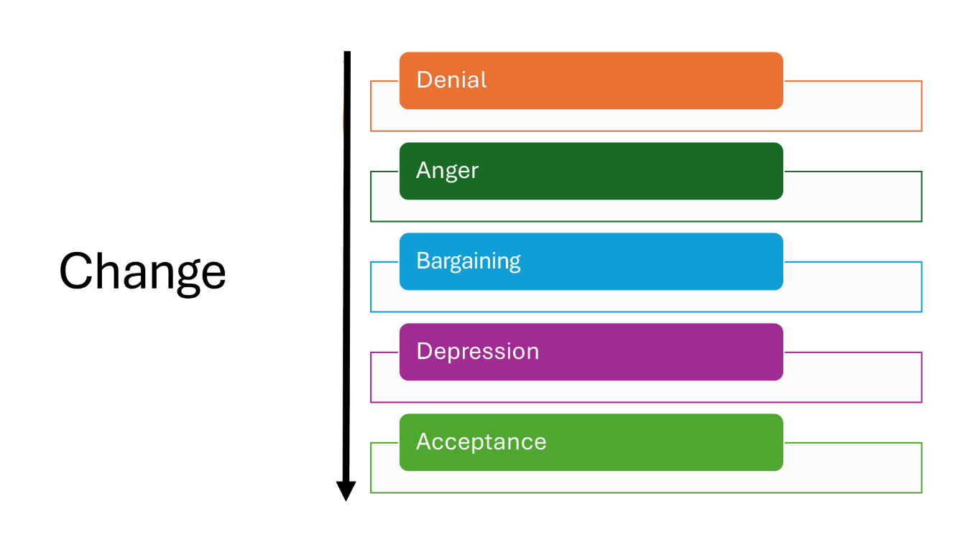

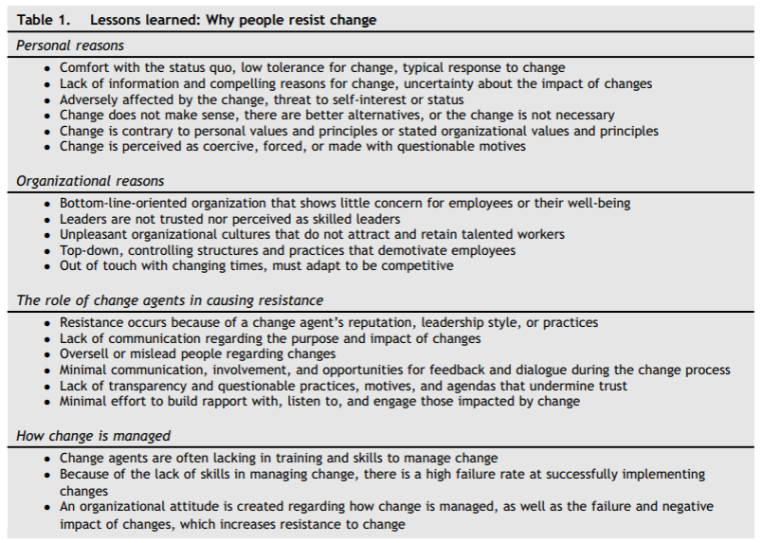
Table from Warrick, D. (2023). Revisiting resistance to change and how to manage it: What has been learned and what organizations need to do ⁽⁶⁾.
V - Examples of conflict resolution.
- A few staff members of a Sport and Exercise Sciences’ School were reluctant to complete a risk assessment before the start of their project. At the School’s meetings, the health and safety lead delivered presentations providing a rationale behind writing a risk assessment specific to one’s activity as well as examples of hazards, risks and control measures relevant to Sport and Exercise Sciences’ activities. Suggestions were made about the few steps that should be followed before starting a project. Progressively, everyone agreed to complete risk assessments prior to the start of their activity.

- Sue and Alex are both Sport and Exercise Sciences Technicians working together to organise some laboratory-based activities for an open day. Alex wants to work on this project twice a week for an hour, four weeks before the deadline to spread the workload. Sue suggests working on this project for a day or so the week before. Alex and Sue have different working styles and should discuss to find a compromise so they both agree on a way of getting ready for the open day. For example, they could find a middle ground and work twice a week for two hours; two weeks before the deadline.

- A Technical Team disagreed about the timeline of a software update. Some members wanted the update to be made as soon as it was available while others pushed for the software to be updated six months later because the release date coincided with a busy time of the year. The manager suggested to update the software about two months after its release, during a reading week. This accommodated both parties and ensured users would benefit from the update in a timely manner.

VI - Tips and steps for solving conflicts.

One of the best ways to solve a difficulty dividing individuals is to adopt a process called “creative design”. Both parties agree to discuss the
situation as a mutual problem that should have a solution satisfactory to all ⁽²⁾.

- Steps To Conflict Management ⁽¹⁾
Note: discussions and meetings aiming at solving conflicts must happen in the presence of all individuals involved in the conflict.

Images: Unsplash.com

- Structuring answers to be clear and understood.

The PREP method is a powerful way of structuring persuasive answers.
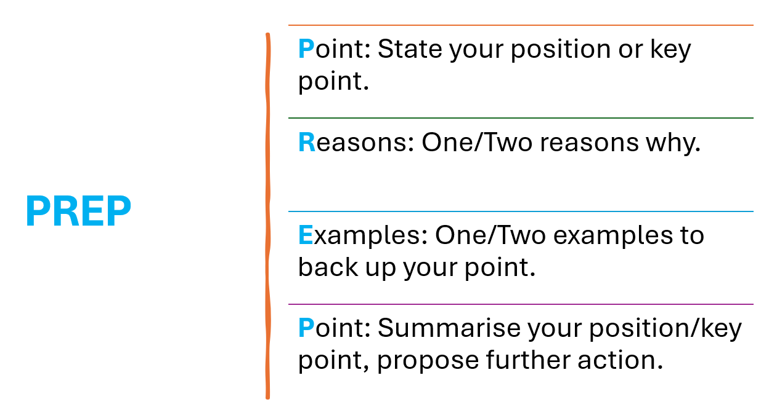
Example of a conflict resolution using the PREP method:
- Point: Wearing a laboratory coat when sampling blood is essential for maintaining safety and hygiene.
- Reason: It provides a protective barrier against potential contamination for both the individual sampling blood and research participant.
- Example: For instance, in clinical settings where bloodborne pathogens like Hepatitis B or HIV may be present, a laboratory coat helps prevent exposure through skin or clothing.
- Point: Wearing a laboratory coat when sampling blood protects individuals and must be included in risk assessment’s control measures.

- Using reflective practice (Gibbs’ Reflective Cycle).

Source: The Open University

- Attending courses:
There are several courses or webinars available that might be useful to help individuals and managers to solve conflicts; below are a few examples:
- Navigating difficult conversations: turn tension into progress.
- Accepting and adopting change masterclass.
- Introduction to conflict management.

References

1 - Ronquillo Y, Ellis V, Toney-Butler T (2023). Conflict management. In: StatPearls [Internet]. https://www.ncbi.nlm.nih.gov/books/NBK470432/

2 - Harolds J & Wood B (2006). Conflict management and resolution. Journal of the American College of Radiology; 3(3):200-206. https://pubmed.ncbi.nlm.nih.gov/17412040/

3 - Cooke L (2006). Conflict and challenging behaviour in the workplace. Journal of Perioperative Practice; 16(8):365-366. https://pubmed.ncbi.nlm.nih.gov/16939162/

4 – Thomas K & Kilmann R (1974). Thomas-Kilmann conflict mode instrument (TKI). APA PsycTests. https://doi.org/10.1037/t02326-000

5 - Tyrrell P, Harberger S, Schoo C, Siddiqui S (2023). Kubler-Ross stages of dying and subsequent models of grief. In: StatPearls [Internet]. https://www.ncbi.nlm.nih.gov/books/NBK507885/

6 – Warrick D (2023). Revisiting resistance to change and how to manage it: What has been learned and what organizations need to do. Business Horizons; 66(4):433-441. https://doi.org/10.1016/j.bushor.2022.09.001.

--
Romain Denis (MPhil., CSci., MCASES, ILM2)
Senior Technical Officer - Sport Scientist
Dublin City University - Glasnevin campus
School of Health and Human Performance
Dublin 9
Ireland

